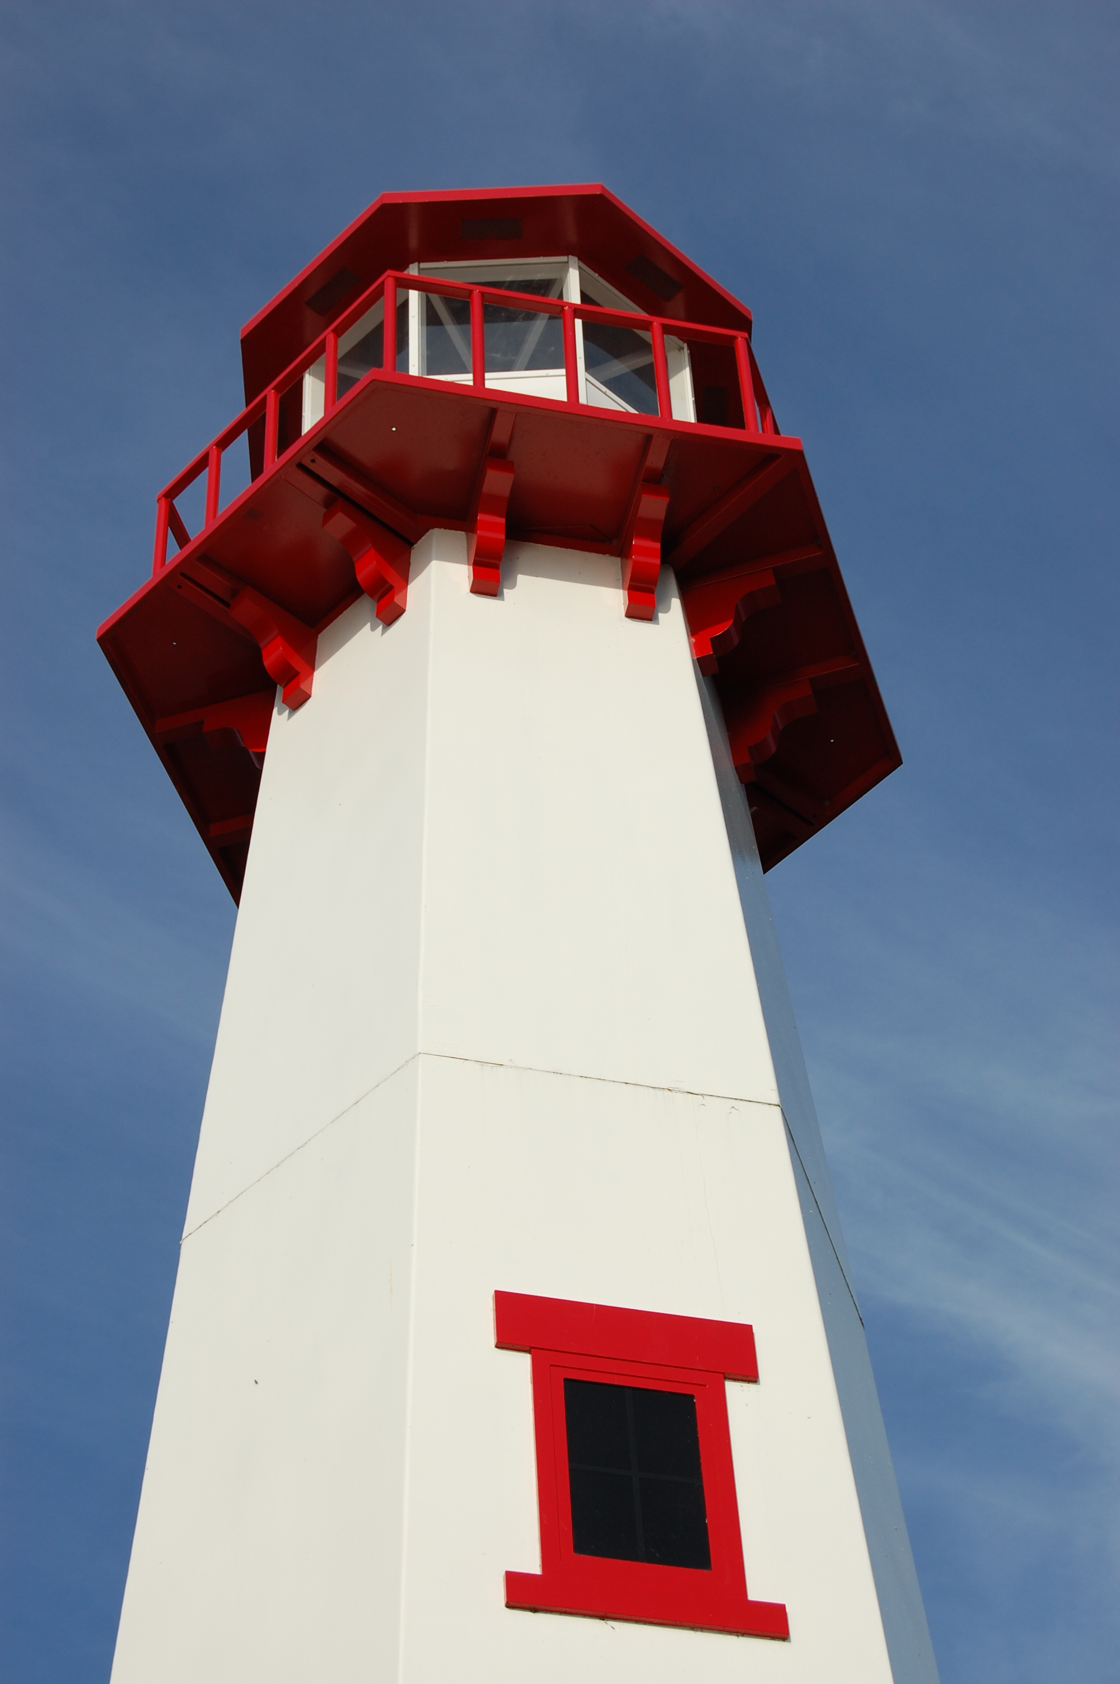
THE LIGHTHOUSE

Newsletter for October 2017

Blessed are those who have learned to acclaim you, who walk in the light of your presence, O LORD.
Psalm 89:15

Message from Our Pastor

Dear Sisters and Brothers in Christ,

Many years ago, I remember talking to a dear friend about a situation that was troubling me. I remember telling him “it feels like all I can do is pray about it”. His response was something that touched me deeply. “David, praying is the most you can do, put it in God’s hands and trust the Holy Spirit will guide you on what needs to be done”. And just recently at a Clergy retreat on Mackinac Island the guest speaker said pretty much the same thing, how the power of prayer is transforming and powerful in the life of the church.

I have tried to live that way since then. To be honest, trusting that God will see me through it has been easy at times. Now we all have struggles and doubts, but once I have walked through those struggles, I have realized that it hasn’t let me down yet. Yes, there have been times when I’ve had to wait for an answer. And there were times when the outcome was totally different than what I had been expecting. But God, through the Holy Spirit, saw me through it, and for that I give thanks.

The Church is in difficult and challenging times. Finances and declining attendance, over the years, are two of the biggest issues. We’re not alone in this situation. Many churches are experiencing these challenging times across the nation. I wish I had an answer for how we can fix this problem, but I don’t. I do know where to begin, and that’s with prayer.

With October, church activities are beginning to pick up. As we try new and different things, along with the things we have been doing, I invite you to join me in prayer. On Fridays from 10:00-10:30 a.m., I invite you to join me for a time of prayer in the sanctuary at Zion. We will be asking for the Holy Spirit to guide Zion, Trinity, and our community around us, down paths of discovery while trusting God’s plan for us in the future.

We can also pray for anything or anyone you wish. I have placed a prayer box in the Family Life Center at Zion and will soon have one at Trinity. So please, if you have a prayer request, put it in the Basket.

Finally, in my office in the parsonage, I have a verse printed on a piece of paper hanging on the wall. It’s 1 Chronicles 28:20 and I think it’s fitting for the times we are in, not only in the church but also in our world. I truly believe we have, as a community of faith, what the world is so desperately seeking today.

‘Be strong and of good courage, and act. Do not be afraid or dismayed; for the Lord God, my God, is with you. God will not fail you or forsake you, until all the work for the service of the house of the Lord is finished’.

May October be filled with the blessings of a beautiful fall season.

Yours in Christ, Pastor David

Newsletter

In memory of our parents

John Reuben Gustafson
1900-1977
&

Mildred Gustafson
1914-2006


the Newsletter was adopted by Carol & John Watson, Sharon & Ken Smith, Tom & Joyce Gustafson,
Ernie & Paula Gustafson, and Pega & John Kennedy

Sunday School


SUNDAY SCHOOL for pre-school to

5th grade students will begin the first

Sunday in October. Class will be held

during the service. If you are

interested in getting involved,

give Pastor David a call. We look

forward to seeing you soon!!

Noisy Offering

Because of the overwhelming need, we will be having noisy offerings for the first 3 weeks of October to go toward Lutheran Disaster Response.

Adult Bible Study

Bible Study at Trinity will be Tuesdays at 6 pm.

Prayer Time with Pastor

Join Pastor on Friday Mornings at 10 a.m. for a time of prayer in the sanctuary. If you are unable to make it and have a prayer request you would like pastor to pray for, leave a note on a folded piece of paper in the collection plate, or in the prayer basket in the family life center.

Women’s Group

On October 8th, the Ladies of Zion will meet after church

Pasties

We need volunteers to make pasties on October 28th and 29th to raise money for the church to cover outstanding bills. Donations of money and ingredients and people to take orders will also be appreciated.

Thank you!

I want to thank everyone for their generosity in work and donations for the Lion’s dinners. Your help is appreciated.

Confirmation

Confirmation will begin on October 29th from 5 to 7 pm

Birthdays in October

October 1 Dylan Shepard
6 Kristen Olsen
6 Saylor Sorenson
8 Teagan Ferguson
9 Jeff Gamble
19 Ray Baron
20 Madison Olsen
22 Katti Gamble
23 Ivan Schlehuber
25 Logan DeKeyser
25 Ken Smith
25 Michael Gustafson (and Lara)
26 Judy Massey
27 Steven Campbell
27 Kristi Gustafson
27 Mike Wilkins
27 Jeanne Rose

Anniversaries in October

October 11 Ray & Shari Baron
15 Mike & Barb Lehto
27 Dave & Rita LaVake

Baptismal Anniversaries

October 5 Sara Sorenson
5 Anthony Lester

7 Sarah Doran
11 Nicole Garen
17 Michael Lennington
17 Jim Ryerse
17 Gavin St. Onge
20 Les Therrian
23 Gary Sorenson
24 Gunnar Olsen
25 Jon Olsen
25 Sally Idalski
25 Haley Dodds
27 Andrew Sjogren
27 Jacob Sjogren
28 Denise Maxson

Trinity Worship Families

Oct 1 Kennedy Family
Oct 8 Movalson Family
Oct 15 Rose Family
Oct 22 Baron Family
Oct 29 Chalmers Family

Zion Funeral Committee October - January

Team Leader: Lorraine Graham (643-8419)
Co-leader: Lana Lennington (643-6576)

Servants for Zion

Ushers & Greeters
Oct 1 Confirmation Youth
Oct 8 Alan & Betsy Turf
Oct 15 NOIZ
Oct 22 Hilda Ryerse & Lynn Evans
Oct 29 Nicole Garen Family

Lectors
Oct 1 Sandy Feleppa
Oct 8 Cathie Tielbar
Oct 15 Fred Feleppa
Oct 22 Betsy Turf
Oct 29 Lynn Evans

Communion Assistants
Oct 1 Lorraine Graham
Oct 8 Karen Schlehuber
Oct 15 Mary Christiansen
Oct 22 Karen Schlehuber

Acolytes
Oct 1 Josh Feleppa
Oct 8 Brendan Donovan
Oct 15 Josh Feleppa
Oct 22 Brendan Donovan
Oct 29 Josh Feleppa

Altar: Susan Fenlon
Money Counters: Susan & Jerry Fenlon

The Usher duties are:
- Arrive 30 minutes before church
- Pass out bulletins and welcome guests
- Help with the offering and communion
- Record attendance

Council Meetings

Trinity Council – October 17, 6 pm
Zion Council – October 25, 6:30 pm

Zion’s Council Members
President: Steve Christiansen 298-1051
Vice-President Karen Schlehuber 643-0311
Co-Treasurers: Dawn Akers 643-7552
Co-Treasurers: Lana Lennington 643-6576
Secretary: Lorraine Graham 643-8419
Mary Christiansen 235-6123
Robert Marshall 643-8936
Dena Barker 430-1460
Paul Shepard 984-2069

Trinity’s Council Members
President: Jerri Rose 292-5570
Vice-President Sharon Chalmers 292-5440
Secretary: Tracy Movalson 292-5581
Treasurer: Pega Kennedy 292-5633
Co-Treasurer: Jim Rose 292-5570
Financial Secretary: Tom Gustafson 292-5460
WELCA: Pega Kennedy 292-5633
John Kennedy 292-5633
Lois Movalson 292-5581

Treasurer's Report for Zion
January 1, 2017 through September 25, 2017
Income:
 | Amazon Smile Foundation | 52.2
 | Building | $ 80.00
 | Church Use Income | $ 1,015.00
 | General | $ 41,436.21
 | Fund Raising - Soup Luncheon | $ 1,518.90
 | Thrivent Financial Income | $ 446.00
 | Trinity Share | $ 10,017.89
 | TOTAL |  | $ 54,566.20
Expenses:
 | Administration | $ 2,587.84
 | Benevolence | $ 970.40
 | Church Maintenance | $ 10,402.62
 | Education | $ 561.35
 | Parsonage Maintenance | $ 2,625.10
 | Pastoral | $ 36,216.79
 | Worship | $ 3,018.27
 | --To Building Fund | $ 0.00
 |  |  | $ 56,382.37
 |  |  | -1,816.17
*********************************************************
Thrivent Financial Investment Fund |  |  | $ 320.83
General fund balance: |  |  | $ (1,207.60)
Kitchen/Building Fund balance |  |  | $ 256.11
General fund owes building fund: |  |  | $ 80.00
General fund owes Mission Endowment fund: |  |  | $ 7,995.00

Zion Lutheran Council Meeting
September 20, 2017

Council Members Present: Stevan, Mary, Robert, Karen, Lorraine, Dawn and Pastor David

Steve called the meeting to order at 6:35 pm.

Pastor Dave opened with devotions “Fight the Good Fight”.

1. Pastor's Report:
- Pastor performed four weddings and went on numerous hospital visits.
- He will be going to his last “First Call Theological Conference from November 5th to 8th. It will cost $300.
- He saved money by commuting to the Clergy & Spouse Retreat on the Island.
- The Joint Picnic went well.
- Adult Book Study will be studying the catechism.
- We have 11 students interested in going to “The Youth Gathering” in Texas.
- Confirmation will be starting on Oct 22nd and we have 2 students (maybe 3 if arrangements can be made)
- He would like to do extra “Noisy Offerings” for Lutheran Disaster Response in light of the recent disasters. Dawn suggested going over the list of the Noisy Offering recipients as some may not be necessary any longer. Karen suggested putting it on the agenda for the next meeting. Pastor suggested the Food Truck might be a worthy recipient.

2. Treasurer's Report:
Dawn reported we have two big bills coming up and we are currently “in the hole”. Karen said she would ask the women’s group, after church on Sunday, if they would be willing to donate to those bills. Treasurer's report was discussed and approved.

3. Secretary's Report:
Secretary's Report was approved.

4. Old Business:
- Elevator people haven’t shown up yet. Steve said he called a company downstate that worked on elevators but they said they no longer did work above the bridge. Robert said if all else fails, he will take things apart.
- Robert is currently working on the lights on the lower floor. He should be pretty well done by Tuesday. He and his brother Cliff will be funding this project.
- Robert said he worked on the lock to the secretary’s office and it is now working as well as possible. Robert stated there was a slight extra bill for the deck that we agreed to pay.
- The account at the bank for Mission Endowment has gone dormant which will be costing us money. Steve will contact Fred about getting the paperwork to start using this money.

5. New Business:
- Karen was wondering if we should have a pasty sale in light of our lack of funds. We decided put out a volunteer sheet for the next two weeks to see if we could get people willing to help make pasties. The next two weeks we would put out sheets for donations for the ingredients. We would make pasties on Saturday October 28th.
- We had to fill out our “Corporation Papers”.
- We decided on October 25th for our next meeting. The women’s group will meet on October 8th.

Meeting was adjourned with the Lord’s Prayer at 7:40 pm.

Respectfully Submitted, Lorraine Graham

Halloween

Halloween is a celebration observed in a number of countries on 31st of October. It begins the three-day observance of
Allhallowtide, the time in the liturgical year dedicated to remembering the dead.

Have a safe and happy Halloween!

Riddle me this…

Q. Why couldn’t Jonah trust the ocean?
A. Because he knew there was something fishy about it.

Q. Did Adam ever have a date with Eve?
A. No, just an apple.

Q. Where is the first tennis match mentioned in the Bible?
A. When Joseph served in Pharaoh’s court.

Volunteers needed

We need volunteers for Altar Guild. Doing altar would be for a month, twice a year. The more volunteers, the fewer times you would have to do it. This is an opportunity to be of service to the church.

Long-Term Care

Cedar Ridge:
Cindy Hendricks

Evergreen Living Center:
Nadine Dandona
Barb Lehto
Judy Ryerse

Prayer List

(If you would like someone added to the prayer list, email or call the church)

Mary Belonga, Dave & Lois Movalson, LaTaunya Paquin, Barb Lehto, Bev Kammers, Joe Chalmers, Nadine Dandona, Patty Thibault, Karen Fowler, Delores Marshall, Bill & Sandy Tielbar, Walter & Jane Puccio, Linda Wilkins, Bill Anderson, Karen Kammers Sparks, Joel Morabito, Rick Brown, Eric Rose, Russell Winberg, Tom & Taffy Coffey, Charlie Doud, Richard Galor, Sarah Marolf, Eunice Therrian, Wes Pechta, Lou Hitts, Jack Dyer, Rick Weiss, Toni Leny, Judy Ryerse, Mandy Jones, Carol Watson, Bea Zak, Aiden, Rodney Novenske, John Lata, Jody Gustafson, Gaven Gustafson, Craig Therrian, Cindy Hendricks, Larry First, Billy Milford, Shirley Winberg, Larry Hopper, Ann & Bill Blaine, Owen, Bernie, Molly, the family and friends of Judy Schlehuber Bridges and all of our homebound & in long-term-care


Forturn Lake Camp

GIVING CHALLENGE Fortune Lake has a received a special gift that is a challenge grant to help boost our monthly giving club, the Tenacious 200. We currently have 37 members in the club and are looking for 200. Each member of the club gives a monthly gift at the level they are comfortable with. Together the gifts help make the ministry at Fortune Lake sustainable, give more scholarships and keep our facilities upgraded. Each new gift or increase in gift will be MATCHED each month from now to the end of the year. So, if you sign up now, your gift will be multiplied by four! You can sign up through Paypal on our website or fill out a form and have the gift come directly from your checking account.

FALL FEST SATURDAY, OCTOBER 7th. Please join us for Fall Fest on Oct 7th. Brunch will be served from 9- 11 am, the country store and markets selling baked goods and hand-crafted items will be open all morning. The quilt auction will begin at 11. All proceeds help support the ministry of Fortune Lake Lutheran Camp. You can see some of the items in the auction on our website and don’t have to be present to bid.

REF FEST Jr High Retreat- Nov 3-4 Join us for faith, friends, and fun as we travel back in time to learn about Martin Luther and the Reformation.

UnFinished Object Crafting Retreat Nov 3-5 Bring your favorite craft and let us do the rest. Make friends, get inspired, and finish those crafts at this fun weekend away.

Fortune Lake Lutheran Camp
fortunelake.org 906-214-2267
138 Fortune Lake Camp Rd, Crystal Falls, MI 49920

Contact Information

Pastor David Tielbar may be reached at 906-984-2051 or at david.tielbar6@gmail.com. In an emergency, you can reach the Pastor’s cell phone at (563) 880-4512

Church telephone: 906-643-7870 - Answering machine
The secretary will usually be in the office on Tuesday and Thursday mornings from 9 – 12

To email the church is: ziontrinity950@yahoo.com

The website is at http://zionstignace.com/home.html
- Find us on facebook at www.facebook.com/zionstignace

Zion Evangelical Lutheran Church and Trinity Lutheran Church are congregations of the Northern Great Lakes Synod and the Evangelical Lutheran Church in America.

Trinity’s Sunday Service is at 9 a.m.
Zion’s Sunday Service is at 11 a.m.

